Unit 12 Exercise – Advanced Layouts

CIS 152

# Instructions

1. Download and the starter zip file from cobra to your machine.
2. Clone your GitHub repository that you were introduced to in class on to your local machine. Again don’t place it on a thumb drive or network drive.
3. Create a folder in your GitHub repository for the starter (something like “unit12exercise”). Copy the contents of the starter folder into this folder.
4. Open the html page(s) in your favorite web browser, and then open your browser’s developer tools so that you can debug and inspect your work as you go. Open the **folder of files** in your favorite text editor (like VS Code) so that you can edit the files.
5. Edit the HTML **AND** CSS to make the webpage match the image below. (Make sure to replace {YOUR NAME} with your actual name). Be sure to use Bootstrap’s classes (“container”, “row”, “col-md-xx”) to create the layout. You will have to use nested rows and columns to achieve this layout. Some basic margin and padding will also be required, but for the most part you can accomplish everything with Bootstrap’s grid system.

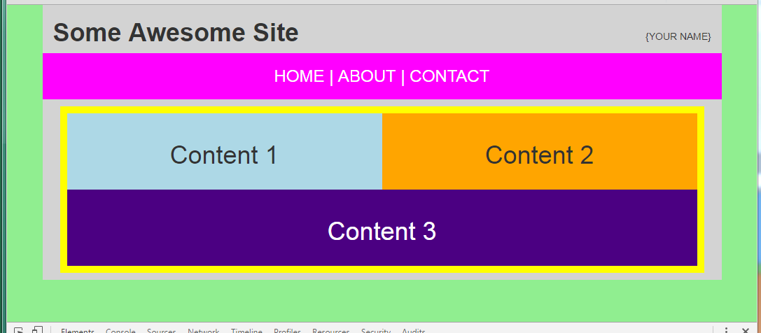

# Submitting

**INSTEAD OF SUBMITTING A ZIP TO COBRA**, when you are done with the assignment, push your code to GitHub. Take a screenshot of the GitHub website showing your commit and submit that to the Cobra Dropbox.